Dashboard Exercise

DELIVERABLE
For this exercise, you will send me the dashboard file that you have saved. This will be part of your deliverables for Assignment #3.

The SQL-To-GoogleChart Dashboard Application

I have created a desktop dashboard application (written in VB .NET) that allows you to create SQL queries and automatically maps the results of these queries to Google Charts. You will use this application throughout the exercises that follow.

Download the SqlToGoogleChartsDashboard.exe program. Execute the program. You should see the following screen appear:

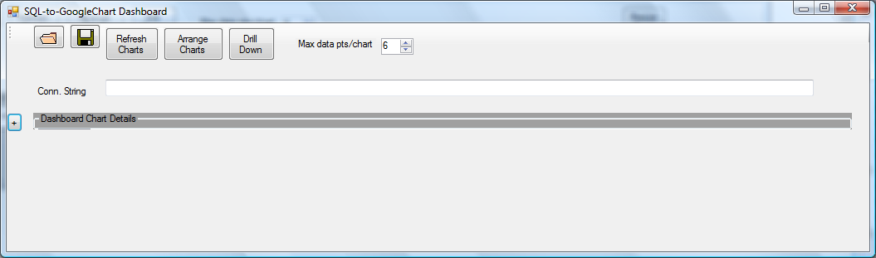

At the top of the screen are five buttons:

1) Open file – prompts you for the dashboard (*.dsh) file to open, then loads the dashboard file.
2) Save file – prompts you for where to save the file, then saves it
3) Refresh Chart – this will cause all queries reprocessed and the resulting google charts for all dashboard items to be to be reprocessed.
4) Arrange Charts – repositions charts based on the size of the form
5) Drill Down – for the selected chart (and aggregate query), generates a new form with charts at the next level of disaggregation.

In addition, there is a Number-up-down control that allows you to specify, for a given query, how many data points will actually be shown in the chart.

The Connection String textbox should contain the connection string for the data source from which you are getting the data. For the purpose of our exercise, you will be using the AdventureWorks database. The connection string for this in the lab is:

Provider=SQLNCLI10;Server=localhost;Database=AdventureWorks;Trusted_Connection=yes;

Copy the above string into the textbox. NOTE: on your own computer, “localhost” may not work. You’ll need to use the SQL Server name that you see in SQL Server Manager Studio on your own computer.

Now, click the button with the plus symbol to the left of Dashboard Chart Details. This will display the following:

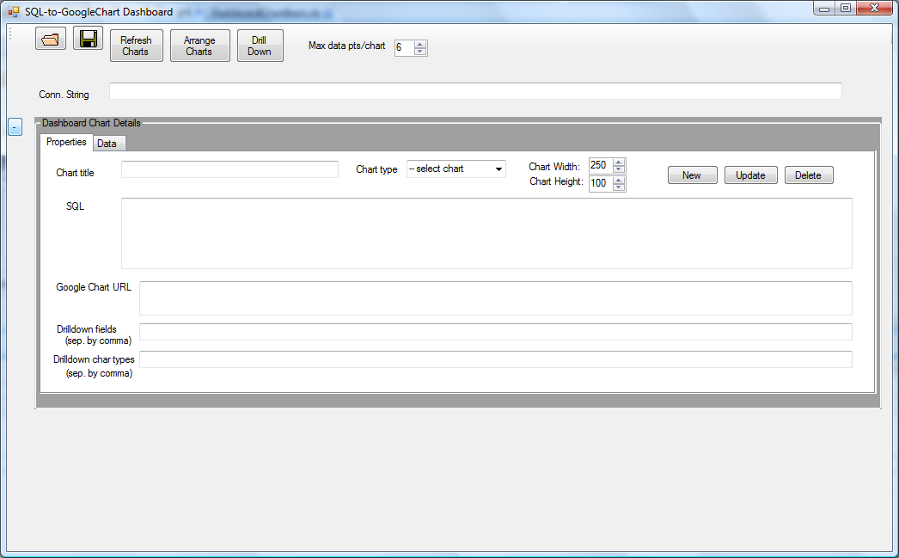

Copy the connection string from above into the Conn. String text box. This is necessary in order to use the AdventureWorks database for generating the data that will go into the charts that you will be creating..

In the Properties tab, you can enter data for a particular chart item that you can create or modify. The Data tab will show the results of a SQL query that you typed in. We’ll see the effects of these in the next section.

Creating your First Dashboard Chart Item

Let’s start by using a query you created in a previous SQL. Put this query into the SQL textbox:

SELECT Production.ProductCategory.Name, COUNT(*)
FROM Production.ProductCategory FULL OUTER JOIN
Production.ProductSubcategory ON
Production.ProductCategory.ProductCategoryID = Production.ProductSubcategory.ProductCategoryID FULL OUTER JOIN
Production.Product ON Production.ProductSubcategory.ProductSubcategoryID = Production.Product.ProductSubcategoryID
GROUP BY Production.ProductCategory.Name order by count(*) desc

For the chart type, choose “horizontal barchart”. Set the chart title to “Product Category Counts”. When you’ve done this, the form should look like this:

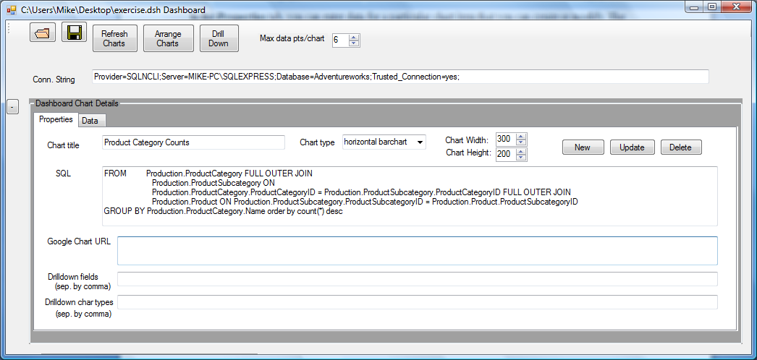

Now, click the New button. This will cause a new chart to be created. Note that the Google Chart URL textbox will have the appropriate text for a generated chart. The form will look like this:

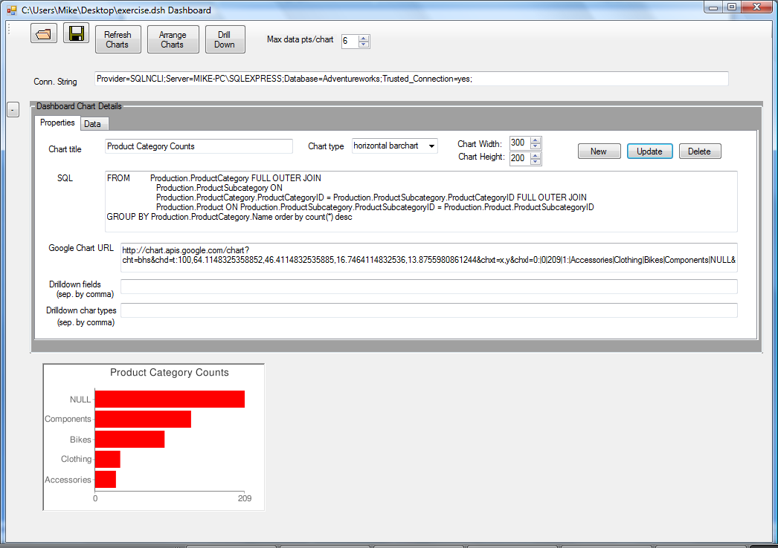

Click the Data tab. You will see the results of the query:

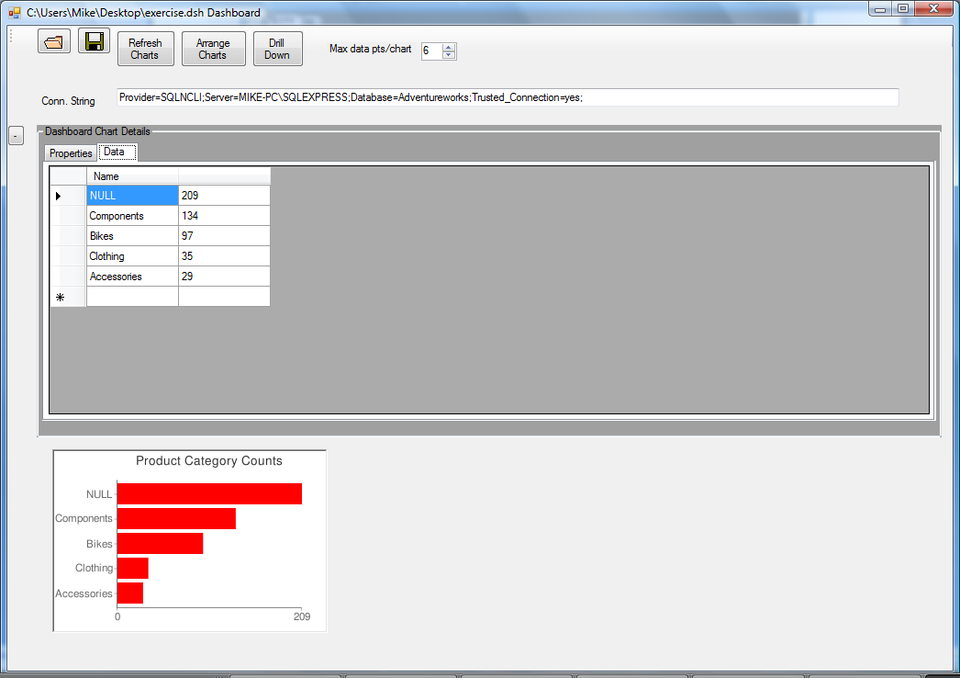

Click the Properties tab again. Experiment with different chart widths and heights. Each time you do this, click the Update button to cause the chart to be regenerated. Try different chart types. Specifically, try the piechart and vertical barchart and linechart options. Each time, click the Update button to regenerate the chart.

You can toggle the +/- button on the left of the form to show or hide the chart item details. Try doing this.

Now, save your work. Click the Save button and give the file a name.

Exit the program.

Creating a Second Dashboard Chart Item (using a Map)

Google Charts allows you to create various types of maps. These include world maps, maps of various continents, and a US map. In this exercise we will generate a world map based on a query that obtains the total number of customers for each country.

First, execute the Dashboard program again. Open the file you saved in the previous exercise. You should see that the original connection string, query, and chart image are preserved. This shows that you can build the dashboard chart incrementally over time.

When building map charts, if you want to show meaningful data displayed in the charts, you need to use the appropriate country codes or U.S. state codes. Fortunately, the AdventureWorks database contains the appropriate country codes in the CountryRegion table. And, the StateProvince table contains the appropriate state codes for U.S. states. So, you can perform queries on the AdventureWorks database and show maps based on these queries. This exercise will focus on displaying maps with color-coded regions (countries or states) based on query results on the AdventureWorks database.

The query you want to do is to find the total number of customers for each country. You should use SQL Server Management Studio to build and test this query. If your query is correct, you will get the following results:

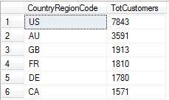

Once you have successfully generated this query, copy the SQL into the SQL textbox in the Dashboard program. Give this chart item the title “Tot Customers by Country”, and choose “world map” as the chart type. Click the New button to generate a new chart item. You will probably find that the new chart item overlaps with your previous chart item (the one showing the product category breakdown). If you click the Arrange Charts button, the charts will be repositioned. Alternatively, you can click on a chart and drag it to the desired position on the form. Note that when you click on one of the pictures, it’s properties and data are shown in the details portion. This way, you can see the underlying SQL and google charts string, and you can also modify properties such as chart sizes, title, etc. for an already generated chart.
If all goes well, your dashboard form will look like this:

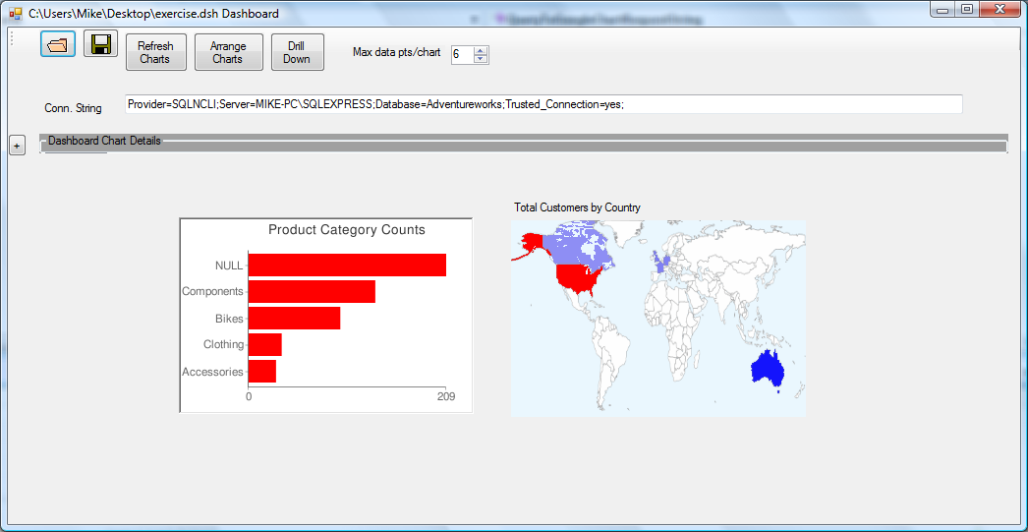

Note that the color-coding I used for the map is as follows:

1) all countries or states that are NOT included in the query results will display as white.
2) countries/states with actual query values will be displayed in a color gradient that goes from grey to blue and finally to red. The highest-valued country/state will appear as red.

Save your work. !!!

You can now exit your program if you are want.

Using the Drill-Down Feature of the Dashboard Application

Drilling down is a process of successive disaggregation. You will see lots of drilldown when we do OLAP exercises later in the semester. Note that the queries we have done so far have both been aggregate queries, and this is generally what you want for dashboards and for business analytic types of information presentation.

The Dashboard application allows you to select a chart and drill down to get more detailed information about that chart. In order to do this, you will make use of the Drill Down Fields and perhaps the Drill Down ChartTypes textboxes in the Properties tab of the chart details section of the form.

Let’s start with the Product Categories chart. If you select this chart on the form, the details Properties area will look like this:

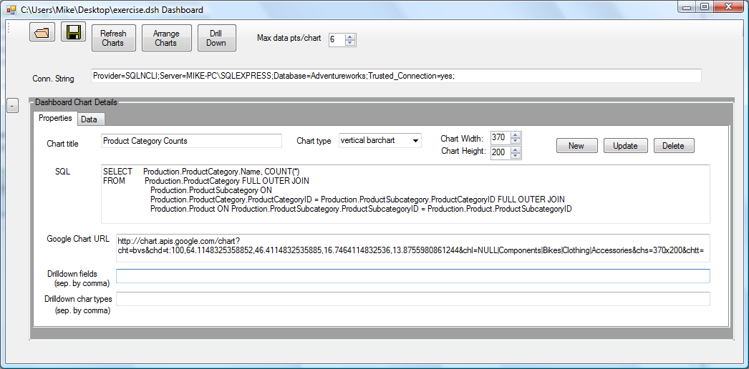

In the Drilldown fields textbox, enter this field name: Production.ProductSubcategory.Name . Click the Update button to make this permanent. Then click the Drill Down button. A new form will pop up displaying the subcategory breakdowns for each category, as shown below:

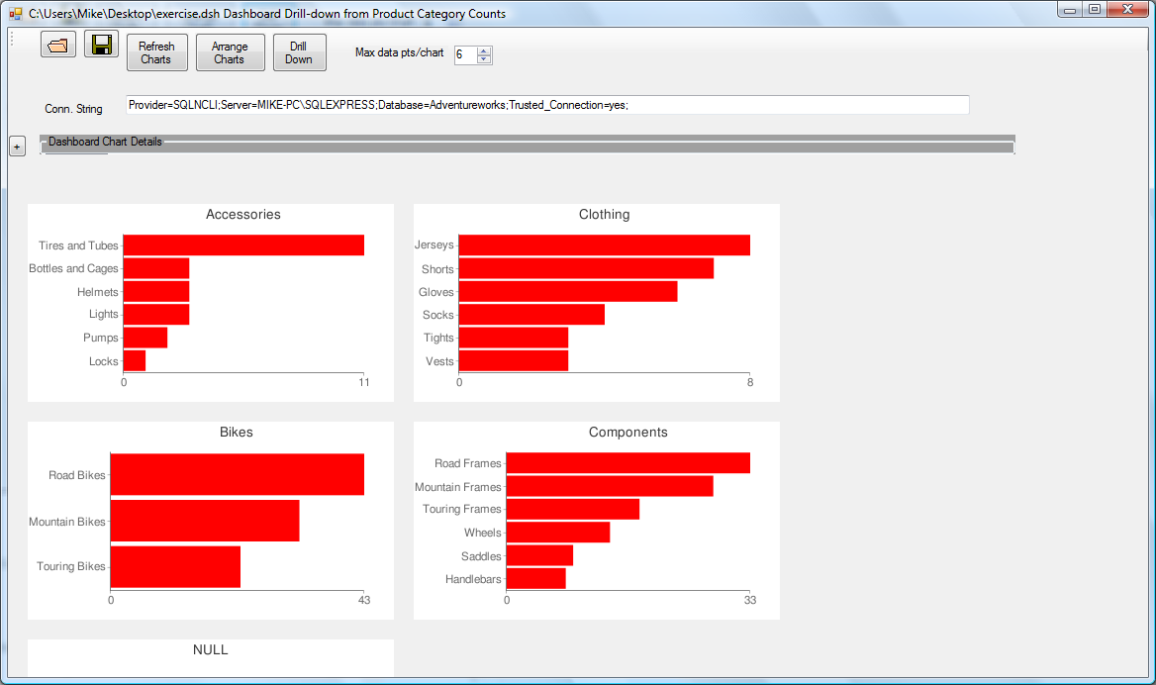

You can select each of these charts to see the details in the Properties and Data tabs.

In this case, we started with an aggregation query at the Category level, and based on this, the drill down produced a more detailed, or disaggregated, query for each category. Look carefully at the original query and then compare this to the disaggregated queries. As a general rule, what drill-down really means is “progressive disaggregation”.

Exit from this second form. Go back to the first form.

Save your work!!

Now, let’s do a slightly more sophisticated drill-down. In this case we will give two levels of disaggregation, and also specify different chart types for each level of drill-down. For this one, select the world map. If you select this one, the form would look something like this:

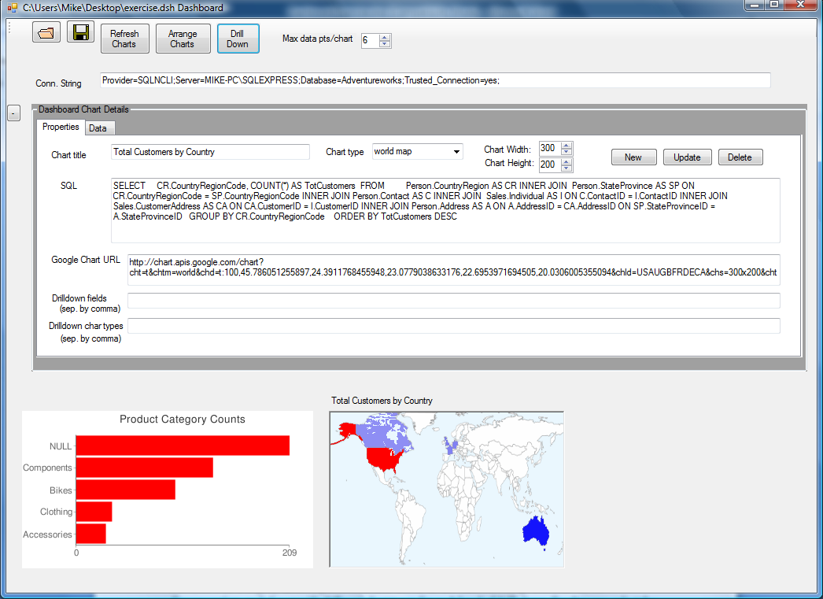

What we’d like to do is drill down on (1) the state/province and (2) the city within the state or province. Also, we’d like to specify other chart types for each level of drill-down. Specifically, the first level will be a vertical bar chart and the second will be a pie chart.

In the Drilldown fields textbox, enter this: StateProvinceCode, City
In the Drilldown charttypes textbox, enter this: vertical barchart, piechart

Click the Update button to make this permanent. Then click the Drill Down button. The following form should appear:

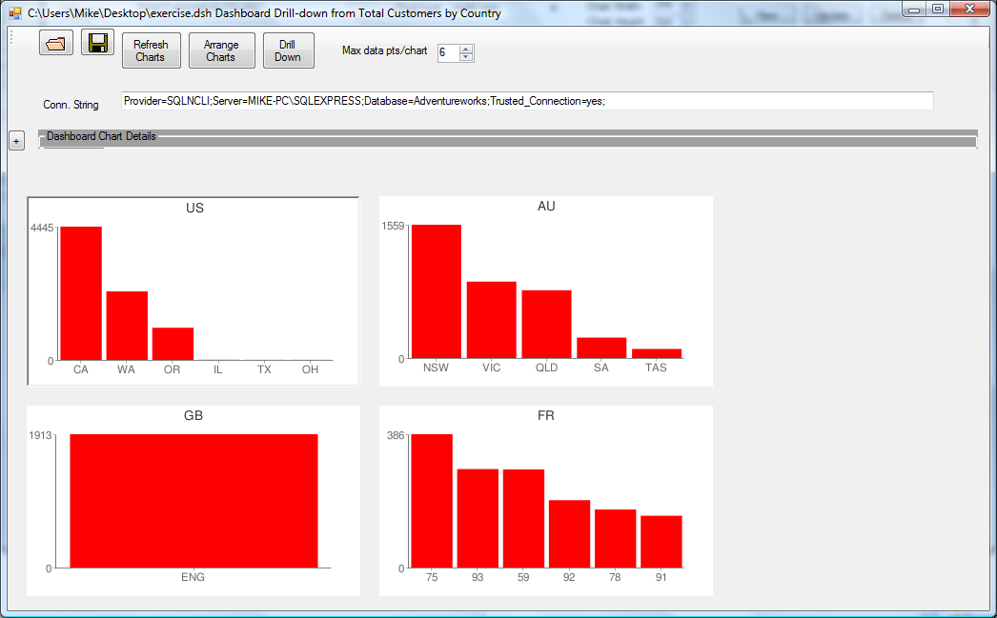

In the new form, select one of the charts. Then click Drill Down again. A third form will appear that looks like this:

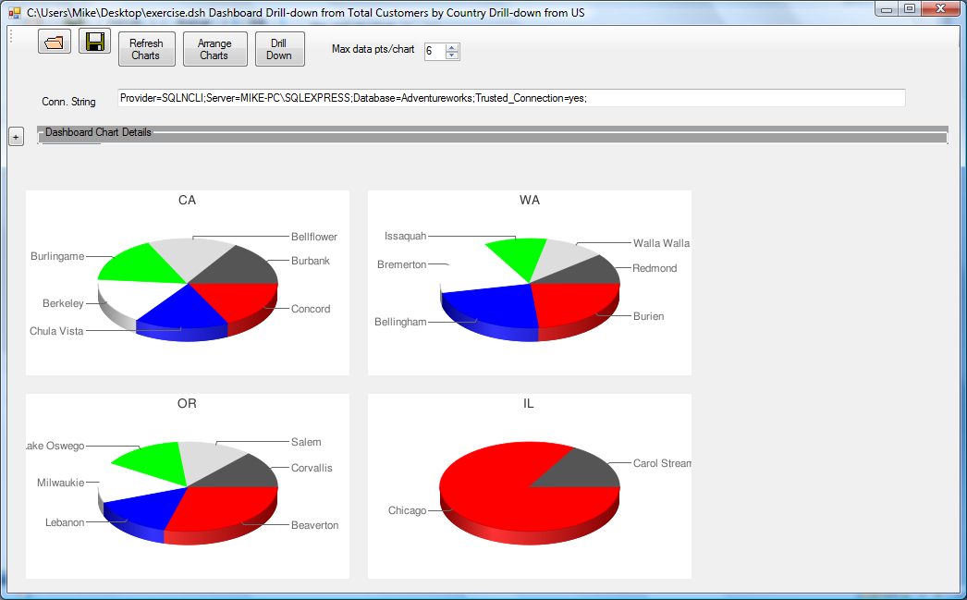
Note that you can save the drill-down forms as new dashboard files, and then reload them later if you want.

Go back to the original form, and save your work!!!

